Linear Regression

Linear regression
Linear regression is a statistical technique used to find the relationship between variables. In ML, linear regression finds the relationship between features and label. For example, we want to predict a car’s fuel efficiency in miles per gallon based on how heavy the car is and we have this dataset:
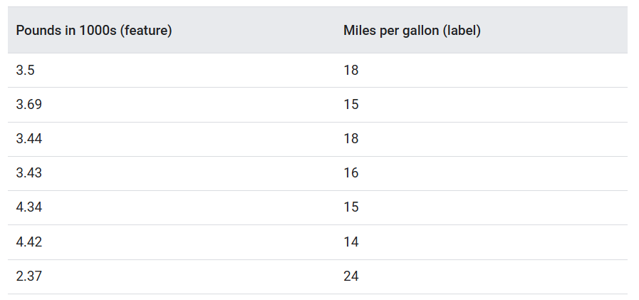
From which we get the following graph:
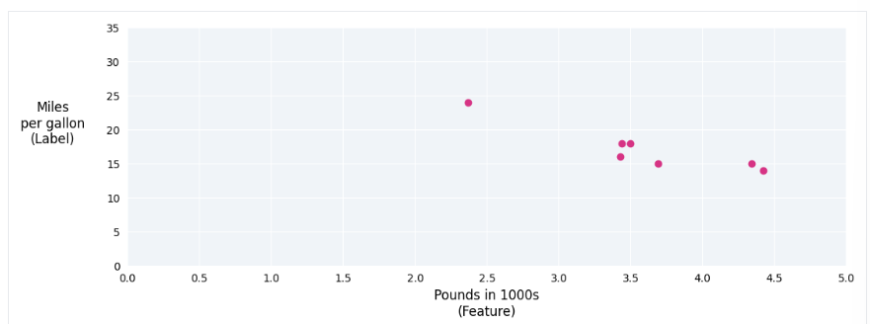
We could see that the heavier the car, its miles per gallon rating generally decreases. We could create our own model by drawing a best fit line through the points.
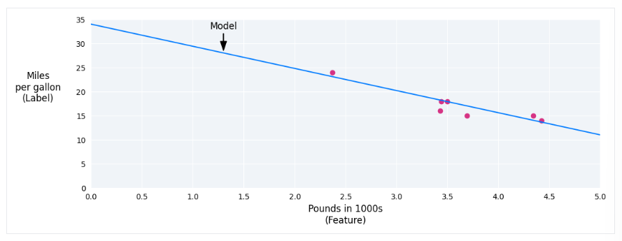
This is called a regression technique.

Linear Regression Equation
In algebraic terms, the model would be defined as $y=mx+b$ where:
- $y$ is the value we want to predict b
- $m$ is the slope of the line
- $x$ is our input value
- $b$ is the y-intercept
In ML, we write the equation model as follows $y^{'}=b+w_{1}x_{1}$ where:
- $y^{'}$ is the predicted label, the output
- $b$ is the bias of the model. It is the same concept as the y-intercept. In ML, bias is a parameter of the model and is calculated during training
- $w_{1}$ is the weight of the feature. It is the same concept as the slope. It is also calculated during training
- $x_{1}$ is a feature, the input
During training, the model calculates the weight and bias that product the best model.

Models with multiple features
The example provided before only use one feature, the weight of a car, while usually a model might rely on multiple features, each having a separate weight. For example, it can be written as follows:
$$y^{'}=b+w_{1}x_{1}+w_{2}x_{2}+w_{3}x_{3}+w_{4}x_{4}$$
For example, a model that predicts gas mileage could additionally use features such as:
- Engine displacement
- Acceleration
- Number of cylinders
- Horsepower
By graphing these additional features, we can see that they also have a linear relationship to the label, which is miles per gallon:
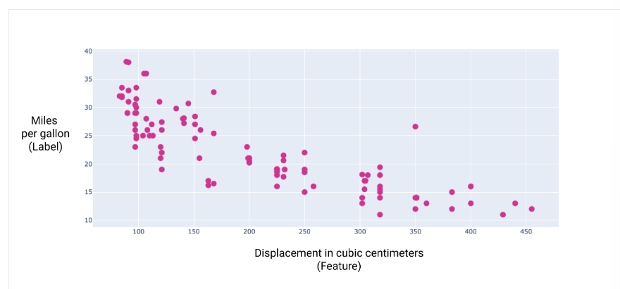

Loss
Loss is a numerical metric that describes how wrong a model’s predictions are. Loss measure the distance between the model’s prediction to the actual labels. The goal of training a model is to minimize the loss, making it as low as possible.
In the following image, we can visualize loss as arrows drawn from the data points to the model. It shows how far the model’s predictions are from the actual values.
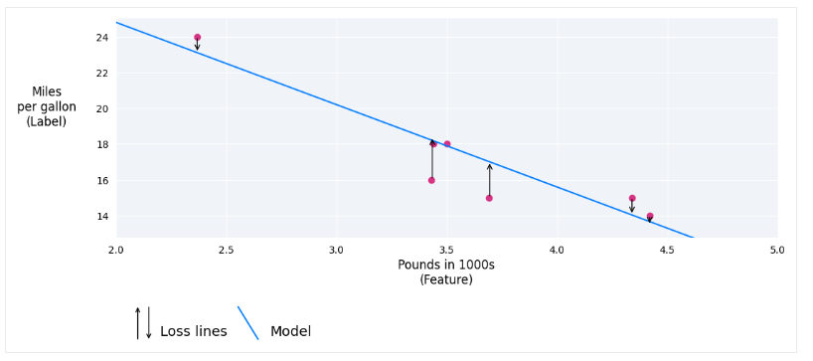

Distance of Loss
In statistics and ML, loss measures the difference between the predicted and actual values. Loss focuses on the distance between the values and not the direction. For example, if a model predicts 2 but the actual value is 5, we will count the distance between the values as 3 not -3. Thus, all method for calculating loss remove the sign. Two most common methods to remove the sign are taking the absolute value of the difference or square the difference between the values.

Types of Loss
In linear regression, there are five main types of loss, which are outlined in the following table.
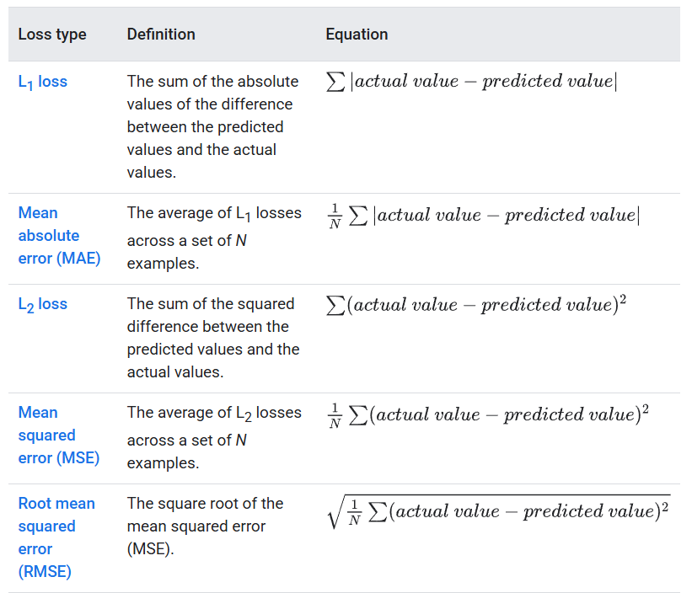
The functional difference between the loss are the squaring. When the difference between the values is large, squaring makes the loss even larger. When the difference is small (less than 1), squaring makes the loss even smaller.
Loss metrics like MAE and RMSE may be preferable because they tend to be more human-interpretable, as they measure error using the same scale as the model’s predicted value

Choosing a Loss
Deciding whether to use MAE or MSE can depend on the dataset and the way we want to handle certain predictions. Most feature values in a dataset typically fall within a distinct range. For example, cars are normally between 2000 and 5000 pounds and get between 8 to 50 miles per gallon. An 8000-pound car or a car that gets 100 miles per gallon, is outside the typical range and would be considered an outlier.
An outlier can also refer to how far off a model’s prediction are from the real value. For example, a 3000-pound car that gets 40 miles per gallon would be an outlier because the model would predict that the car would get around 20 miles per gallon.
When choosing the best loss function, consider how we want the model to treat the outliers. For example, MSE moves the model toward the outliers while MAE doesn’t. This is because MSE makes the difference between predicted value and outlier even larger because of the squaring, while MSE doesn’t. Since the model trained always tried to minimize the loss, the predicted line will move toward the outliers when using MSE. The relationship between the model and the data:
- MSE. The model is closer to the outliers but further away from most of the data points
- MAE. The model is further away from the outliers but closer to most of the other data points.

Gradient Descent
Gradient descent is a mathematical technique that iteratively finds the weights and bias that product the model with the lowest loss. Gradient descent finds the best weight and bias by repeating the following process for a number of user-defined iterations.
The model begins training with randomized weights and biases near zero, and then repeats the following steps:
- Calculate the loss with the current weight and bias
- Determine the direction to move the weights and bias that reduce loss
- Move the weight and bias values a small amount in the direction that reduces loss
- Return to step one and repeat the process until the model can’t reduce the loss any further
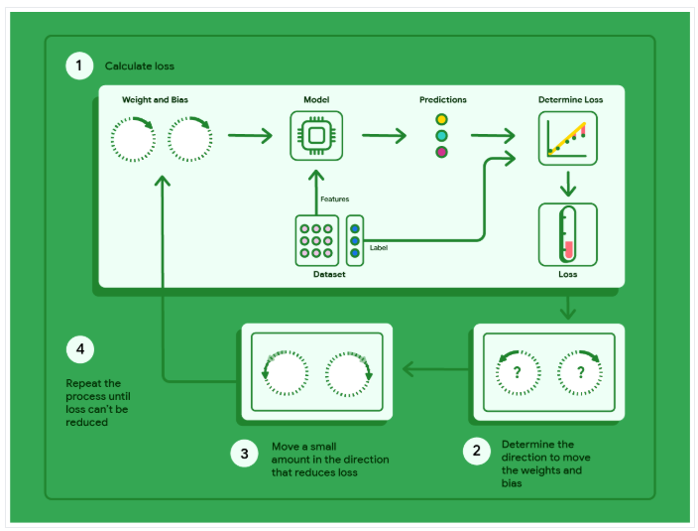

Model Convergence and Loss Curves
When training a model, we’ll often look at a loss curve to determine if the model has converged. The loss curve shows how the loss changes as the model trains. We can see on the image below that loss dramatically decreases during the first few iterations, then gradually decreases before flattening out around the 1000th iteration mark. After that, the model has converged.
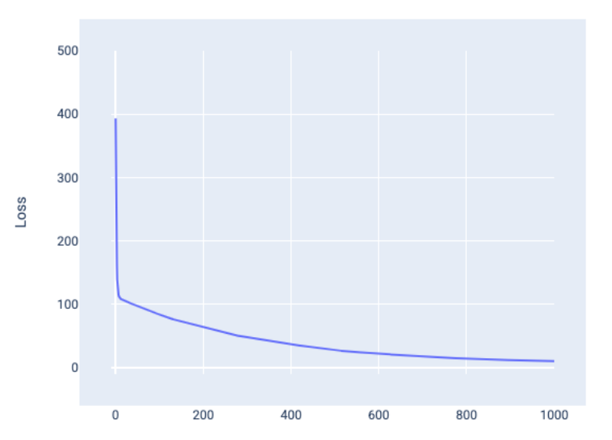

Convergence and Convex Function
The loss function for linear models always produces a convex surface. As a result of this property, when a linear regression model converges, we know the model has found the weights and bias that produce the lowest loss.
If we graph the loss surface for a model with one feature, we can see its convex shape. The following is the loss surface for a hypothetical miles per gallon dataset. Weight is on the x-axis, bias is on the y-axis, and loss is on the z-axis.
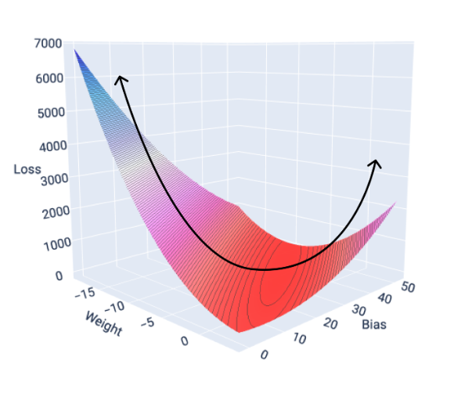

A linear model converges when it found the minimum loss. Therefore, additional iterations only cause the gradient descent to move the weight and bias values in very small amounts around the minimum. It is important to note that the model almost never finds the exact minimum for each weight and bias but instead finds a value very close to it. It is also important to note that the minimum for the weights and bias don’t correspond to zero loss, only a value that produces the lowest loss for that parameter.

Hyperparameters
Hyperparameters are variables that control different aspects of training. Three common hyperparameters are:
- Learning rate
- Batch size
- Epochs
In contrast, parameters are the variables, like the weights and bias, that are part of the model itself. In other words, hyperparameters are values that we control, parameters are values that the model calculates during training.

Learning rate
Learning rate is a floating point number we set that influences how quickly the model converges. If the learning rate is too low, the model can take a long time to converge. However, if the learning rate is too high, the model never converges and instead bounces around the weights and bias that minimizes the loss.
The learning rate determines the magnitude of changes to make to the weights and bias during each step or iterations of the gradient descent process. The model multiplies the gradient by the learning rate to determine the model’s parameters (weight and bias values) for the next iteration.
The difference between the old model parameters and the new model parameters is proportional to the slope of the slope of the loss function. For example, if the slope is large, the model takes a large step. If small, it takes a small step. If the gradient’s magnitude is 2.5 and the learning rate is 0.01, then the model will change the parameter by 0.025 per iteration.

Batch Size
Batch size is a hyperparameter that refers to the number of examples the model processes before updating its weights and bias. When a dataset contains hundreds of thousands of examples, using the full batch isn’t practical.
Two common techniques to get the right gradient on average without needing to look at every example in the dataset before updating the weights and bias are stochastic gradient descent and mini-batch stochastic gradient descent:
- Stochastic gradient descent (SGD): uses only a single example (a batch size of one) per iteration. Given enough iterations, SGD works but is very noisy. “Noise” refers to variations during training that cause the loss to increase rather than decrease during an iteration, The term “stochastic” indicates that the one example comprising each batch is chosen at random. Using SGD, the model will produce noise throughout the entire loss curve, not just near convergence.
- Mini-batch stochastic gradient descent (mini-batch SGD): is a compromise between full-batch and SGD. For N number of data points, the batch size can be any number greater than 1 and less than N. The model chooses the examples included in each batch at random, averages their gradients, and then updates the weights and bias once per iteration.
Determining the number of examples for each batch depends on the dataset and the available resources. In general, small batch sizes behaves like SGD, and larger batch behaves like full batch gradient descent.

Epochs
During training, an epoch means the model has processed every example in the training set once. For example, given a training set with 1000 examples and mini-batch size of 100 examples, it will take the model 10 iterations to complete one epoch. Training typically requires many epochs. That is, the system needs to process every example in the training set multiple times.
The number of epochs is a hyperparameter you set before the model begins training. In many cases, you’ll need to experiment with how many epochs it takes for the model to converge. In general, more epochs produce a better model, but also takes more time to train.
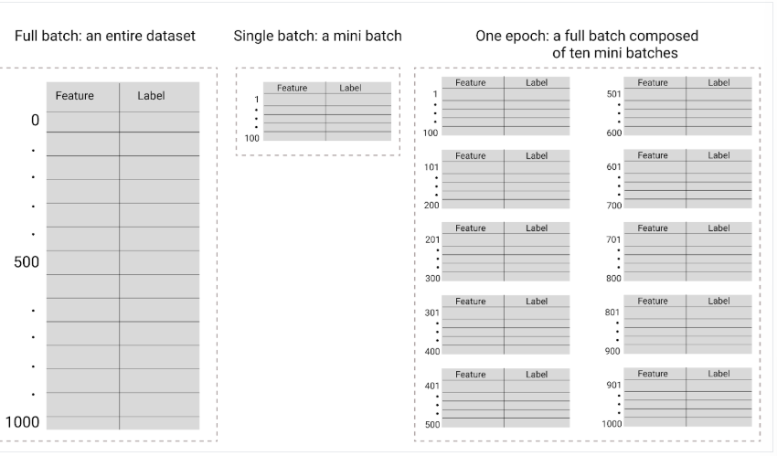

The following table describes how batch size and epochs relate to the number of times a model updates its parameters.

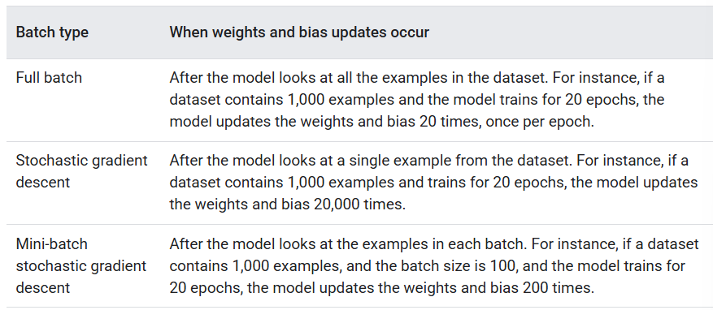

Regularization
Regularization is a way to prevent overfitting and allows the model to generalize better. Even though linear regression is just a single line (or a hyperplane), it can also overfit data. Overfitting is when the model performs very well on training data but results in poor performance on new data., which could happen when a model becomes to complex. This is because the model the training data rather than learning the patterns that are generalized to new data.
Two common types of regularization techniques are Ridge regularization and Lasso regularization.

Lasso Regularization
Lasso regularization, also known as L1 regularization, adds a penalty term to the objective function that is proportional to the absolute value of the coefficients (sum of absolute weights). L1 penalty can shrink some weights to 0. It minimizes the following equation:
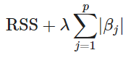

Ridge Regularization
Ridge regularization, also known as L2 regularization, adds a penalty term to the objective function that is proportional to the square of the coefficients (sum of squared weights). L2 penalty shrinks weights smoothly but it keeps all features. It minimizes the following equation:
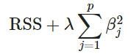
The hyperparameter used to control the regularization is usually lambda (λ) or alpha (α). However, there are some advantages and limitations for regularization:

Advantages:
- Reduces overfitting in machine learning model
- Helps with high-dimensional data and reduces the influence of less important features
- Improves generalization performance
Limitations:
- Too strong penalty can make the model too simple and miss important patterns in data
- Assumes all input variables have equal importance, which may not be true in some cases
- Assumes the data is linearly separable

Alpha
Alpha is the parameter that controls how strong the penalty is applied to the weights. Here is how alpha affects the model:
Alpha (α) | Effect on weights | Effect on model
0 | No penalty | Same as normal linear regression
Small (0.01 – 0.1) | Slight shrinkage | Model is close to linear regression, slight regularization
Medium (1) | More shrinkage | Weights smaller, reduces overfitting more
Large (10+) | Very strong shrinkage | Weights very small, may underfit (too simple)

References
Medium: https://medium.com/@novus_afk/regularized-linear-regression-35d5eaaa84d5
Google ML Course: https://developers.google.com/machine-learning/crash-course/

